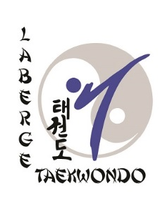

Written essay to obtain your red belt

Purpose:

Make evident certain conditions, situations or acquisitions on your part that have happened since the beginning of your practice.

Talk about the remarkable events that have happened during your evolution in taekwondo.

This essay must reflect your personality. You must do this essay and keep in mind that the traditions and philosophies of taekwondo played a role in your development. All of your reflections on the different aspects of taekwondo, that you will talk about in your essay, must be profound so that it can contribute to your future development in the continuity of your practice.

Please note: This essay must be 4 to 6 pages long. It may be sent to: info@labergetkd.com one month before the date of your exam.

